BESS GABY

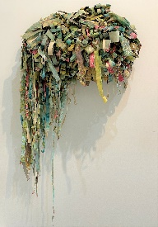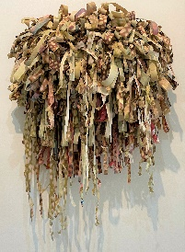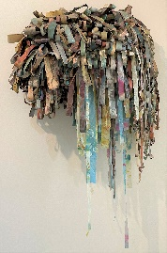

Cactus, Coral, and Bark

2010. Digital Prints, Oil-based Monotype Relief Prints, Handmade Paper, Assorted Japanese and Conservation papers, archival glue on wood and wire frame.

This series titled Decay, highlighted technical skills, use of materials, and concepts related to time, loss, and the environment. My work focuses on simple, repeating patterns, shapes, and colors to produce multiple representations of organic forms.
Using found images of cactus, coral, and tree bark, I manipulated and deconstructed them to reconstruct a new image that represented a universal organic form. The images have been printed digitally on assorted handmade and globally sourced papers. Abstract paintings were then printed on the papers using oil-based relief printmaking inks using a traditional monotype technique. Each strip of paper is totally unique, each fold and curl describes its form-- its own DNA.
My hope with this series was to create organic forms, from organic materials, and over time document their decay. During the processes of digital and monotype printing, I thought a lot about the oils and toxic ingredients in inks I applied. I applied heavy metals, alcohol-based solvents, and industrial cleaning solvents throughout the monotype process in excess to push the inks in such a way that they resembled microscopic organisms. The paper was soaked through and took about a week to dry. I imagined what these oils and toxins would do to the living organisms in the images I was reconstructing.

BESS GABY

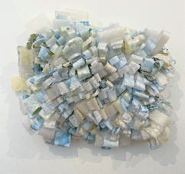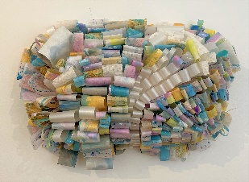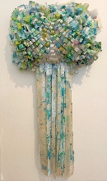

Sky, Sunrise, and Mist

2021. Watercolor and acrylic paintings, Mica, Pearlescent paper, Assorted Japanese and Conservation Papers, archival glue on wood and wire frame.

This work, from a new series titled Weightless, focuses on color, mark-making, and concepts related to pressure, environment, and time. Using memory, feelings, and personal narrative I create paintings that reflect mental images of atmosphere. I deconstruct the paintings and reassemble them to represent atmosphere in a physical form. Each strip of paper is unique, each fold and curl describes its form.

My hope with this series is to focus on the single element that all humanity shares --oxygen. With every inhale, we exhale together. Specifically, these first pieces in this series are positive, an outlook of relief and hope. However, our atmosphere is not physically separated by landmasses, statehood, or ownership. There may be darker days ahead. I have reflected upon this concept much in my personal life and as a global concept throughout the Pandemic of 2020.

