ELIZABETH MADOR

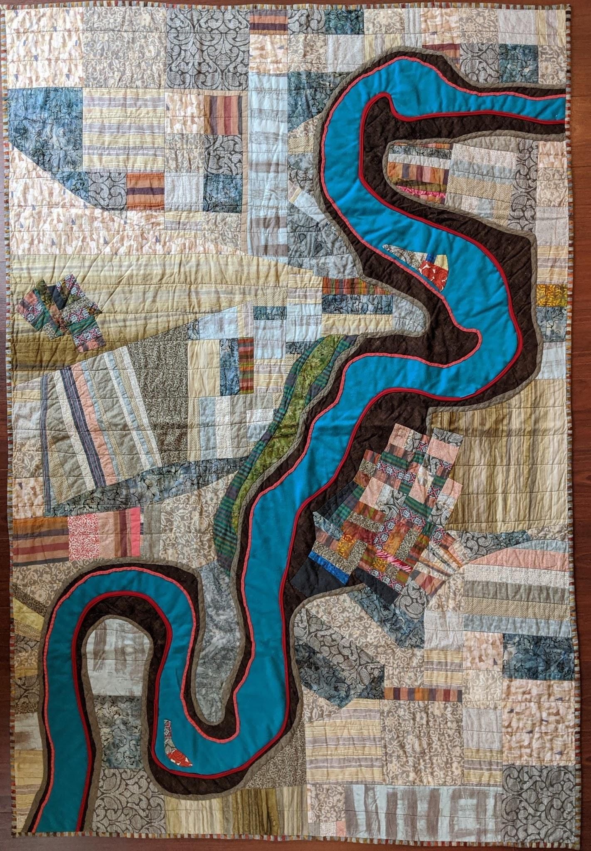

River of Life
50 x 80"
ON LOAN / SOLD

Cotton, linen, polyester and other textiles; hand and machine appliqued and quilted. Cotton/poly batting and cotton backing.

The powerful force of water shaped by external constraints creates the winding path of the river. Its bed and banks, islets and fertile plains, and the gathering of life humming at its edges reflect the winding turns and forces that characterize our own experience of being human. The shape for this river was initially inspired by various aerial photographs of the rivers of China. The fabric in the river with the rose motif is a tribute to my sister Rose, who died in 2018 from breast cancer at the age of 52.

ELIZABETH MADOR

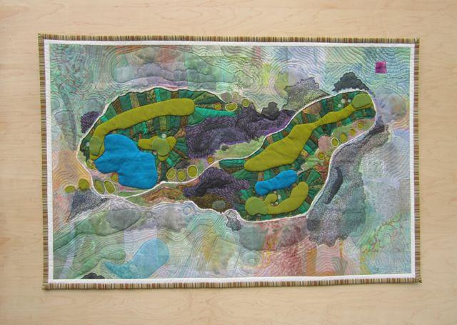

Gold Mountain
24 x 32"

Cotton, rayon, silk and tulle; rayon, silk and cotton thread; dye and acrylic paint; machine quilted, hand-embroidered with silk and cotton floss. Cotton batting and backing.

In 2013, we found ourselves in Bremerton WA on a work assignment. Born in Seattle, I took the opportunity to reconnect with my roots and the physical beauty of the northwest. Gold Mountain is the highest point on the Kitsap Peninsula in the middle of Puget Sound. Nestled in its peaks is a golf course defined by the tallest trees and bluest skies, eagles soaring - a wildness I can’t forget. While John golfed, I would practice yoga at each hole. This piece captures favorite holes 15, 16, 17 and 18. Look closely and you can see the fairways, the greens, the traps and even the tee boxes.

As I developed this composition, I used quite a bit of paint with layering techniques to push back the color surrounding the focal area.

ELIZABETH MADOR
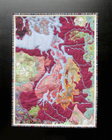

Mapping Puget Sound No. 1
24 x 32"

Cotton, hand-dyed, machine quilted and couched with silk floss; rayon, silk and cotton thread; Australian and Indonesian cotton prints, and hand-marblelized pima cotton. Cotton batting and backing.

This piece depicts the Puget Sound region in Washington State. The inspiring elevation contours of the Olympic Mountains to the west and the Cascade Range to the east, cradling the city of Seattle and the Kitsap Peninsula, led the design process to a finished piece that refers to the complex textures of many old-time maps.

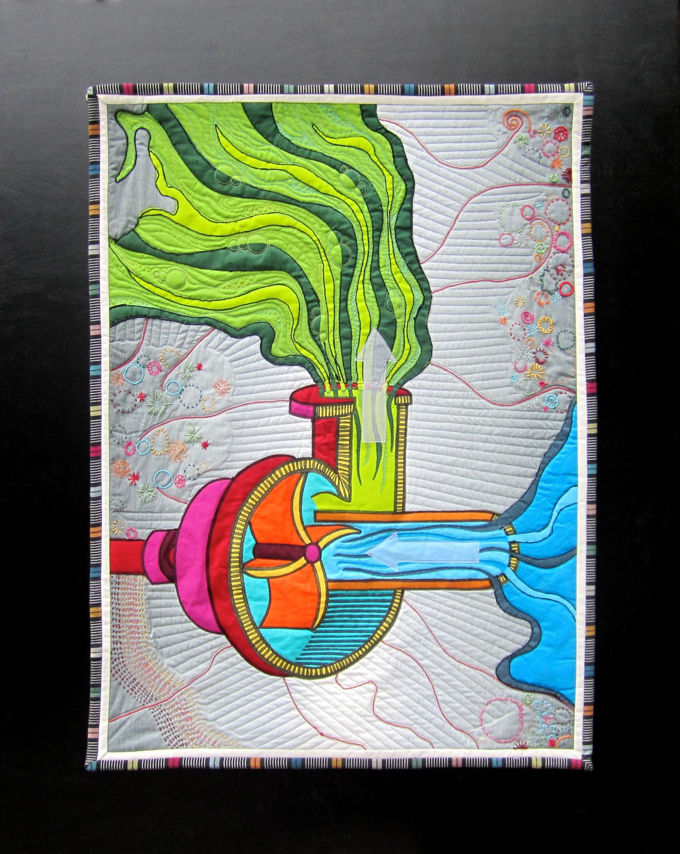

Mapping Puget Sound No. 3
24 x 32"

Cotton and silk organza, machine quilted with bobbin work, and hand embroidered with rayon, silk and cotton threads. Cotton batting and backing.

The third in a series of Puget Sound maps, this work models the Sound on a mechanical pump. While living in Puget Sound, I was enthralled by the vast tides I witnessed as the Sound pulsed in and out so far from the Pacific. The waters
flowing down from the Cascade Range and the Olympic Mountains into the Sound reminded me of a centrifugal pump, depicted here in a section view designed on the same satellite image of Puget Sound as the first two in the series.

ELIZABETH MADOR

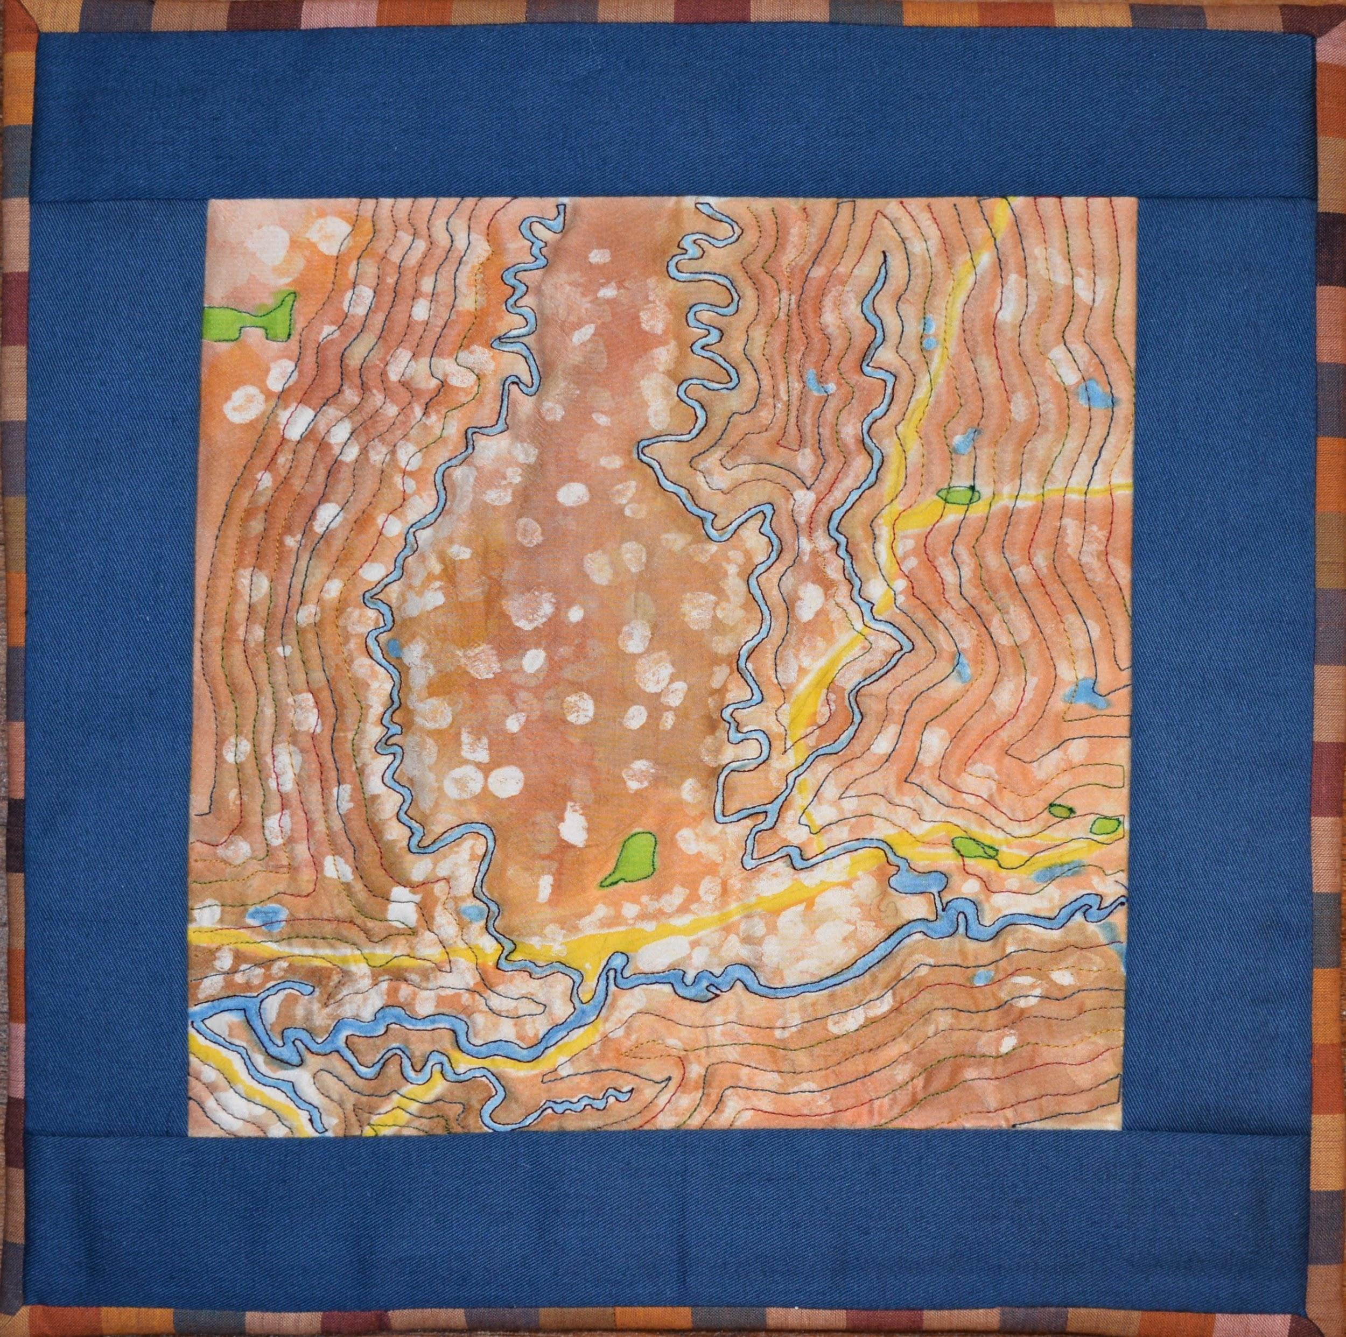

Mapping the Chehalis River WA
10 x 10"

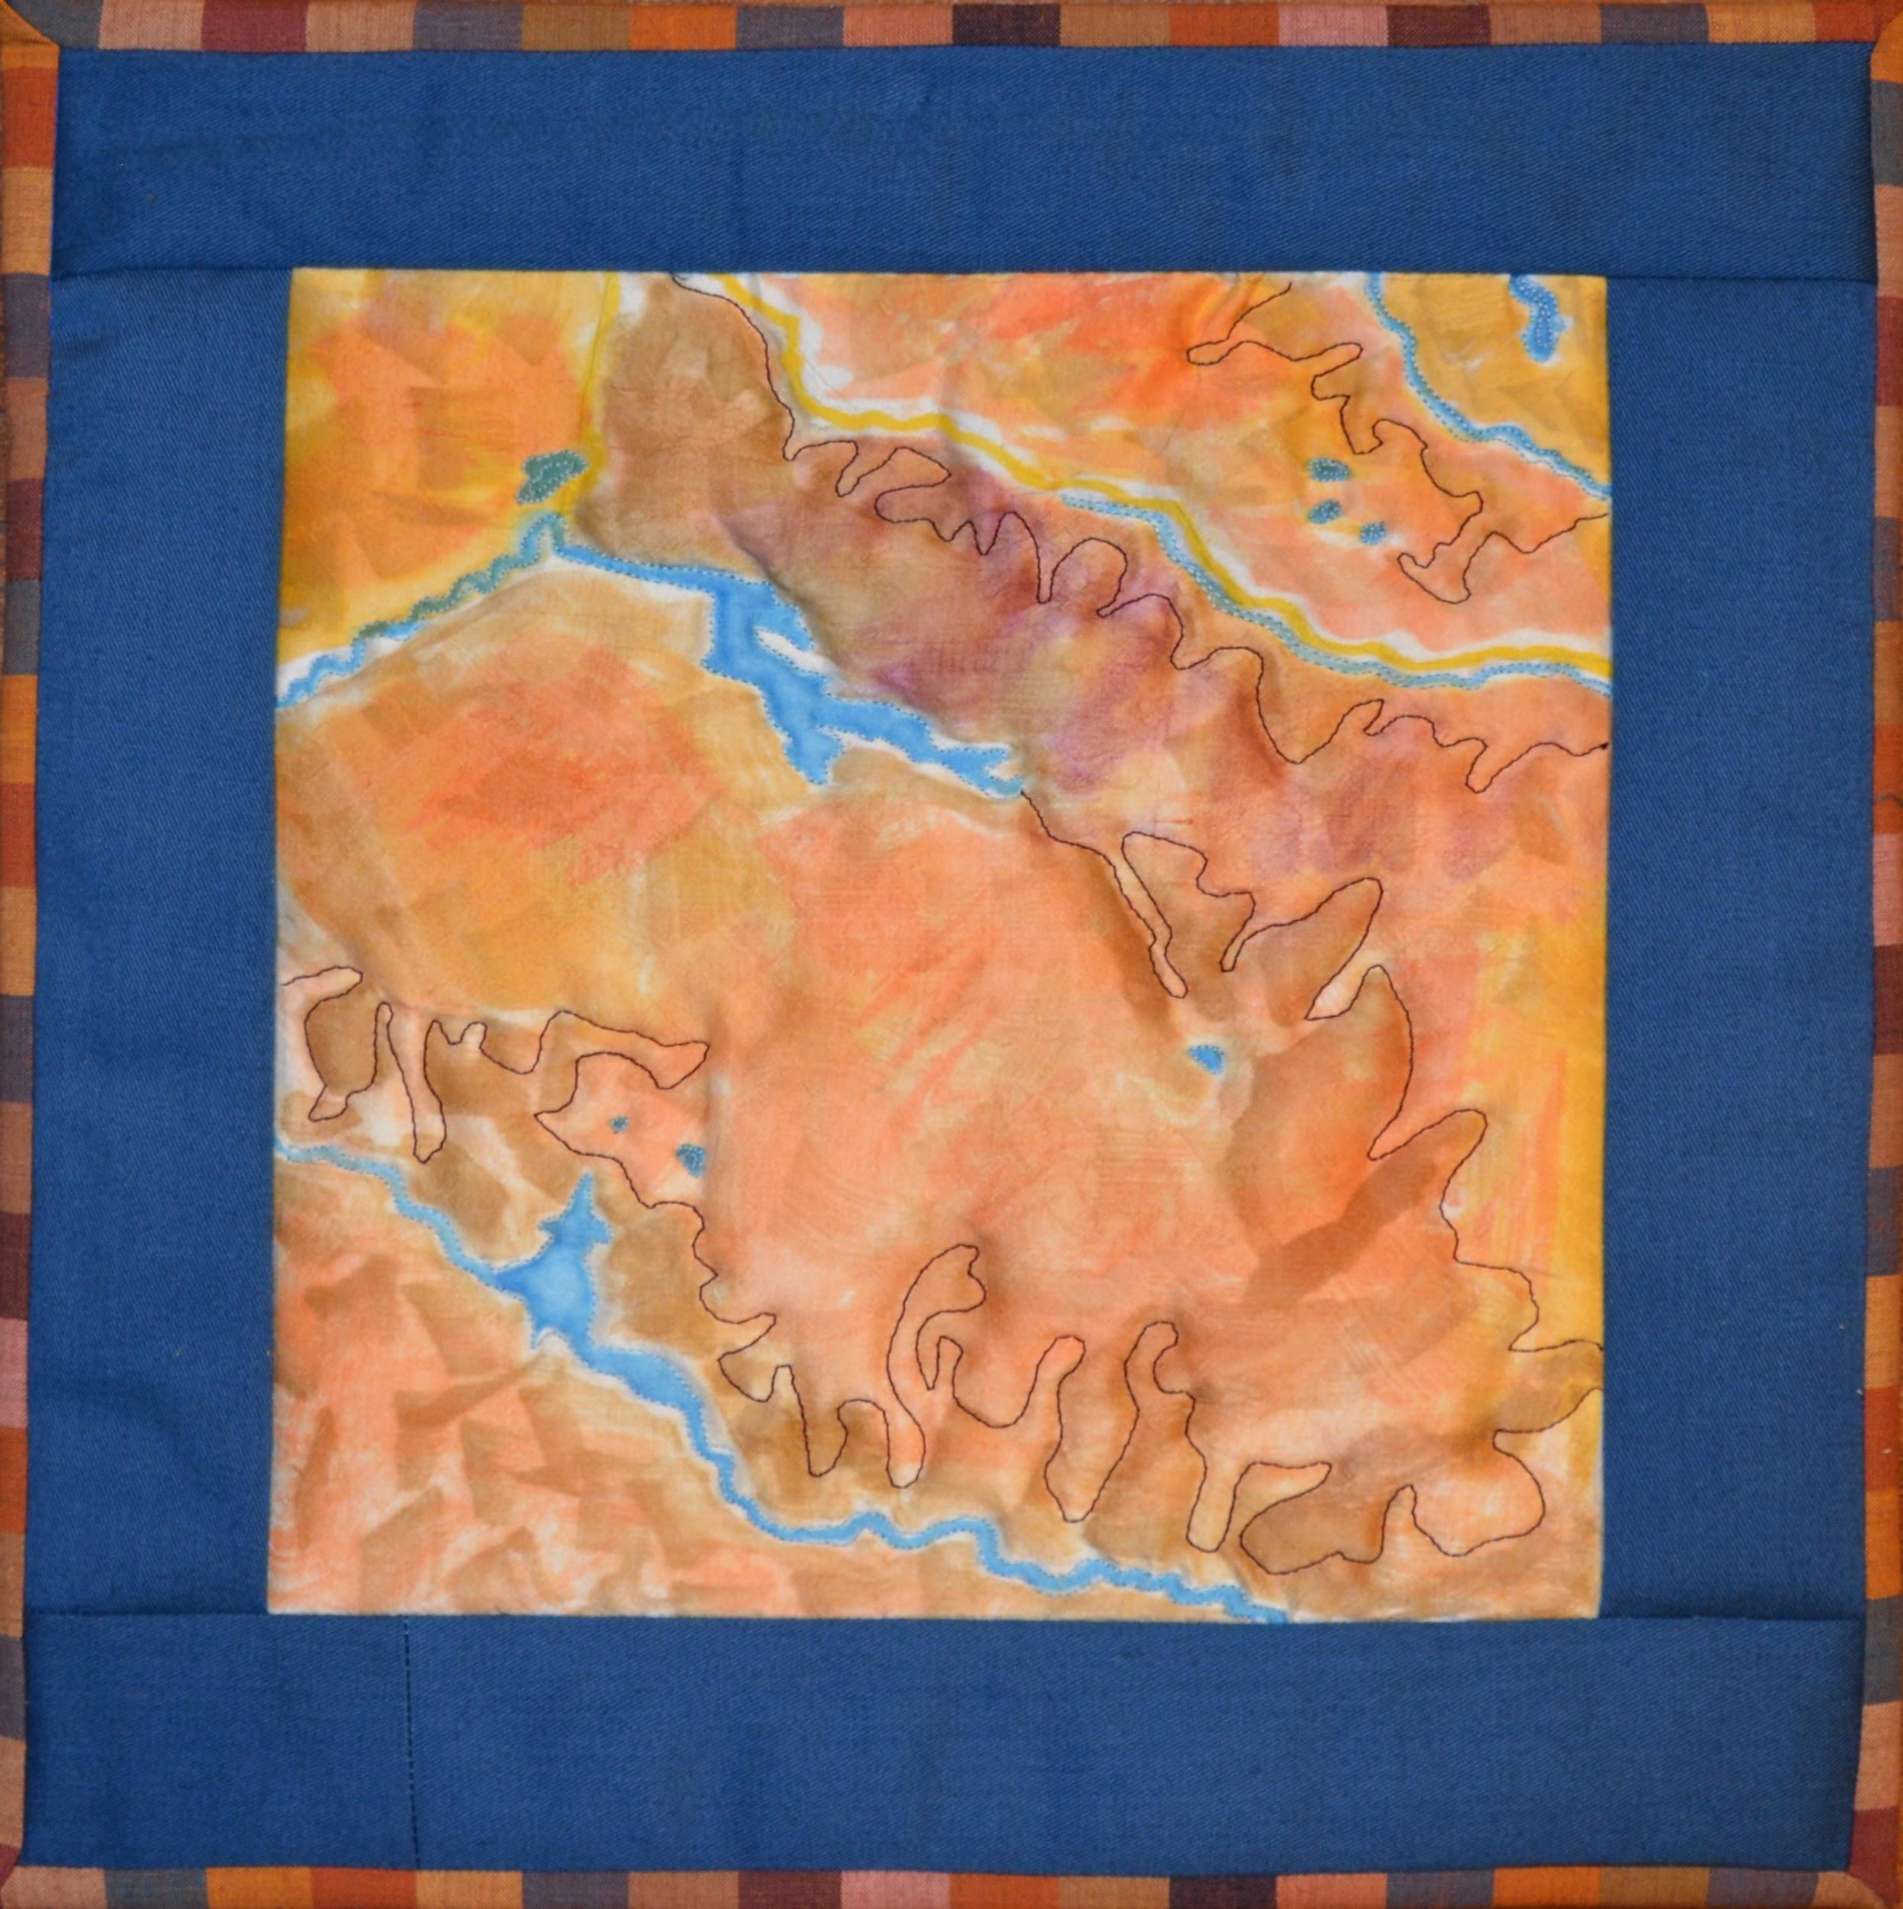

Mapping Chester Morse Lake, WA
10 x 10"

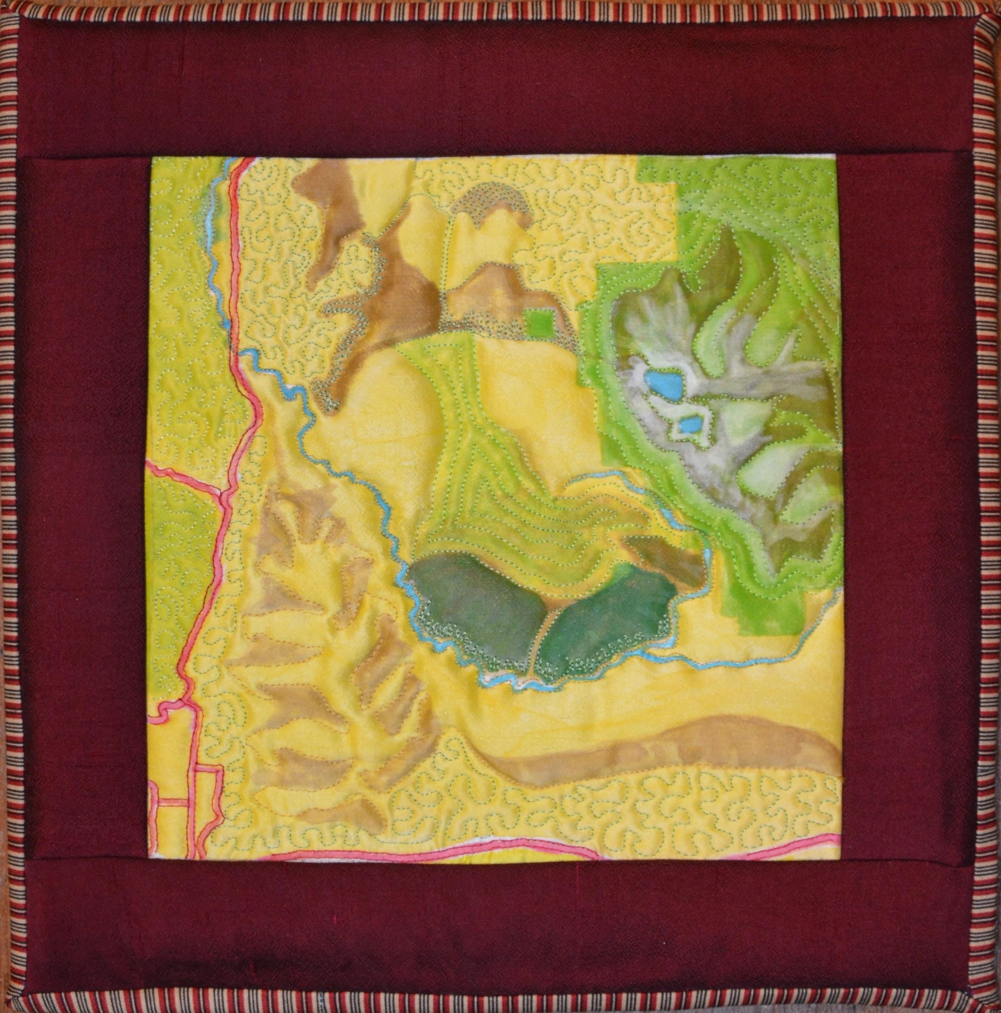

Mapping Lyman Hill, WA
10 x 10”

These small maps are each made from a single piece of white silk. Using Japanese permanent inks and dye-resist techniques, I hand painted the panels and used high loft batting to achieve texture across the surface.
ELIZABETH MADOR
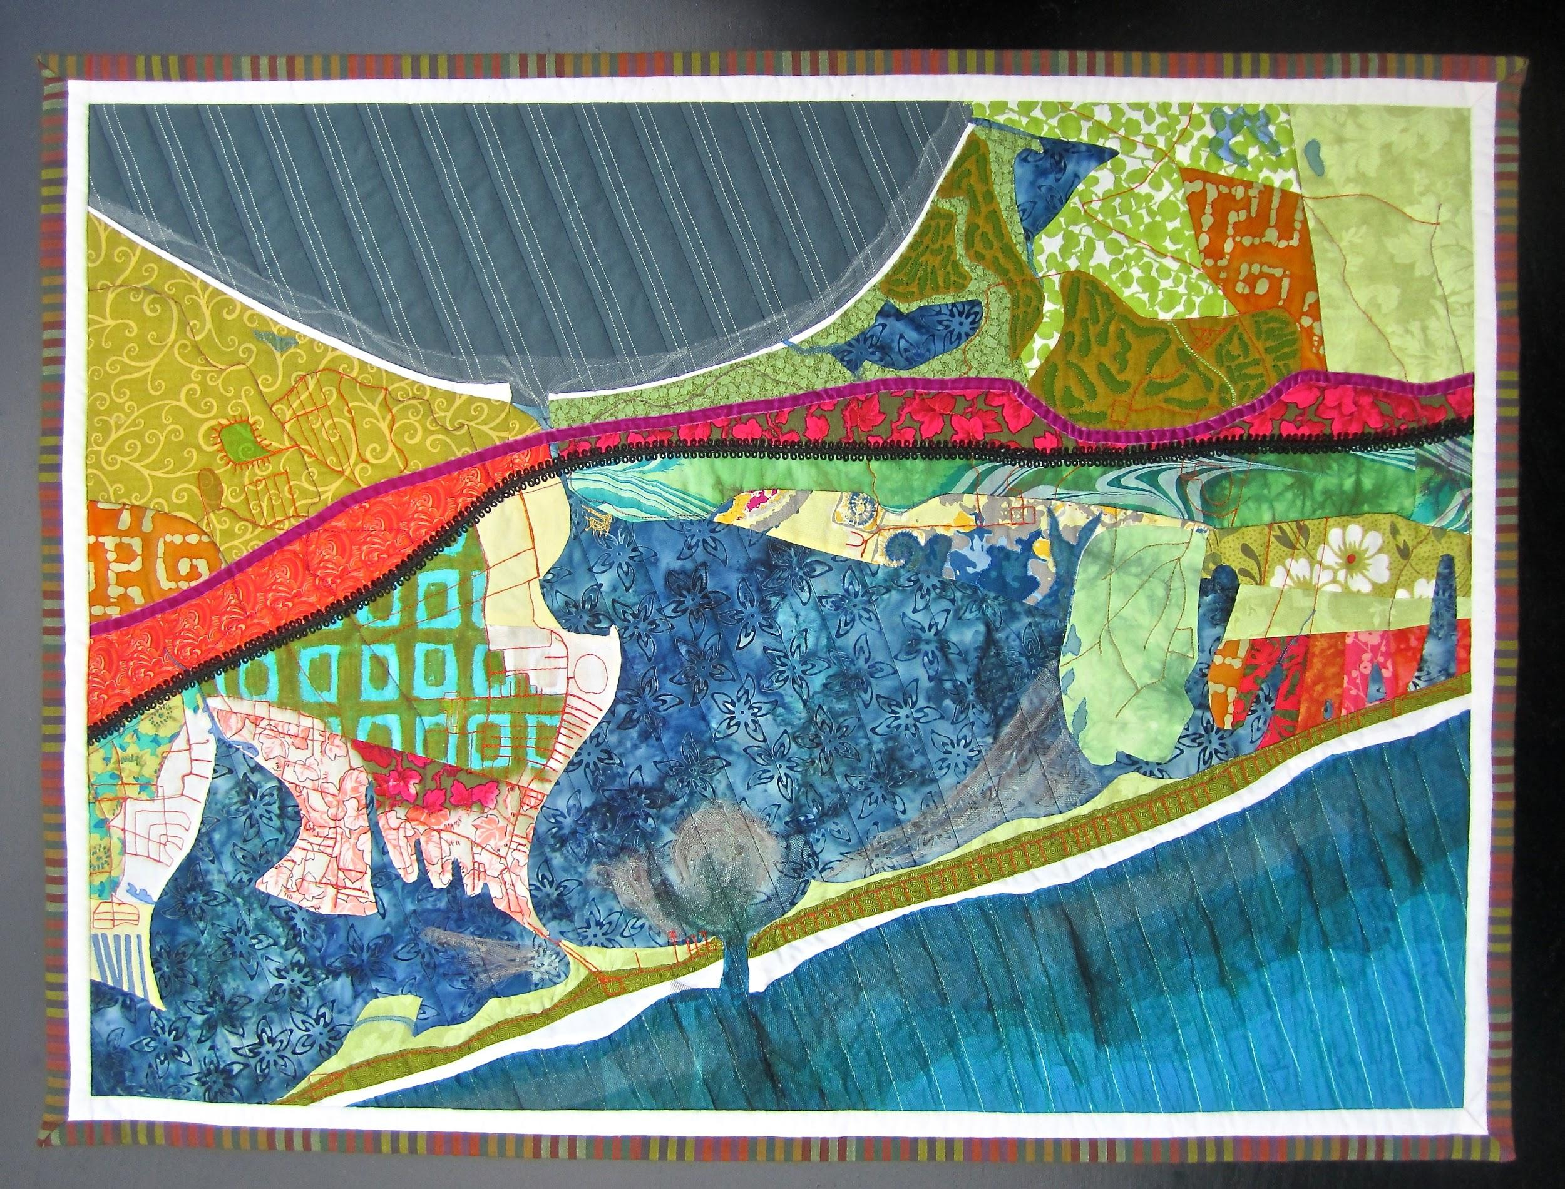

Mapping Shinnecock Inlet / The Hamptons
32 x 24"

Cotton, silk, and tulle, hand-dyed and painted, hand-appliqued and machine quilted; rayon, silk and cotton threads. Velvet and braid trim. Cotton batting and backing.

On the south fork of Long Island NY, Shinnecock Inlet splits the narrow 100-mile-long Outer Barrier, separating Westhampton Island from the Village of Southampton. The name comes from the Shinnecock Indian Nation; the Shinnecock Reservation is a green oval peninsula on the right side of the piece. Formed by the Great Hurricane of 1938 when the Atlantic permanently broke through the island, the inlet - aligned with the Shinnecock Canal directly north - provides a shortcut to north fork boaters through the Peconic and Hampton Bays to the Atlantic Ocean. Shoals at the break are visible in satellite images of the region, like underwater blooms.

Features of the work include Highway 27 in magenta velvet, the Long Island-Montauk Rail in black braid, and four golf courses: Shinnecock Hills, National, Sebonack and Southampton golf clubs are all accurately represented. The stitching over the whole piece follows true road lines. I bleach into the work to subtract commercial dye from the fabric; elsewhere I use dye and acrylic paint and even ink to deepen layers of color as I explore additive and subtractive processes.
ELIZABETH MADOR
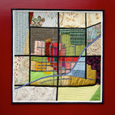

Mapping Oberlin, OH
30 x 30"

Cotton, linen, and dupioni silk; rayon, silk and cotton thread; hand and machine
quilted, hand-embroidered. Cotton batting and backing.

The roads of Oberlin, Ohio, create a grid 13 miles south of Lake Erie, a scaffolding for homes, small businesses, a college, fields and the railroad.

The town's past provides a different sort of grid. Conceived as an integrated community by two ministers, the town grew into a focus of the abolitionist movement and a terminus on the Underground Railroad. Its history provides the scaffolding for the strongly felt presence of progressive Oberlin College, where black students attended since 1835. I worked on a book to capture the big mission, conscience, and heart of this college, and came away in love with the landlocked aerial of its geographic features and, conversely, how it defies being contained or grounded. Oberlin is a place that is bigger than its grid.

ELIZABETH MADOR

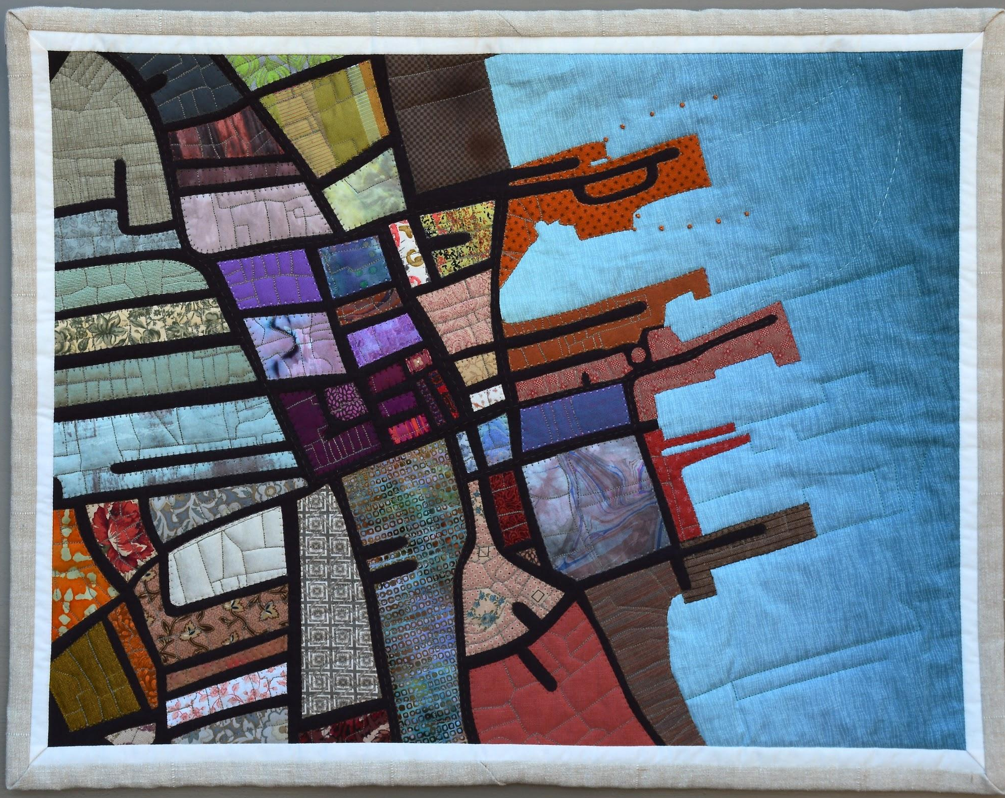

Mapping Nantucket Town, Massachusetts
24 x 20"

Cotton, linen, and dupioni silk; rayon, silk and cotton thread; hand and machine quilted, hand-embroidered with silk and cotton floss. Cotton batting and backing.

Representing the streets, AND faithful to the actual property lot lines of old town Nantucket, the celebrated and historic island harbor village streets are quilted accurately into the panel. Wharves and the waterfront are key elements in this composition, and ferry lines are indicated with hand stitching.

ELIZABETH MADOR

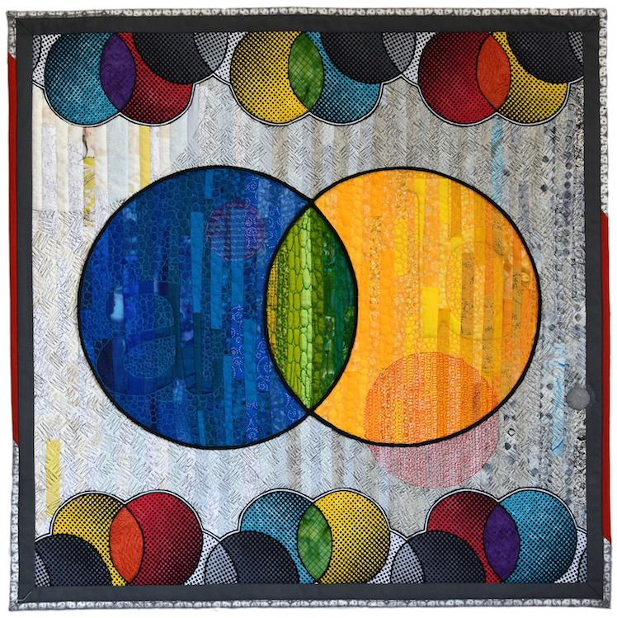

Venn
30 x 30"

Cotton, rayon, silk; rayon and cotton thread; piping; machine
quilted, hand-embroidered, hand dyed. Cotton batting and backing.

The classic Venn. Simple set theory, not-always-so-simple relationship diagram. Applicable to nearly everything. What’s YOUR “a” and “b”? How much do they overlap?

The inspiration for this piece was a beautiful black and white textured textile from the Netherlands that you can see on the top and bottom borders. Applying dye and threading and applique technique made the second layer jump to life in color. I featured the motif as the central image, investigating transparency and hue in this familiar diagram.

ELIZABETH MADOR

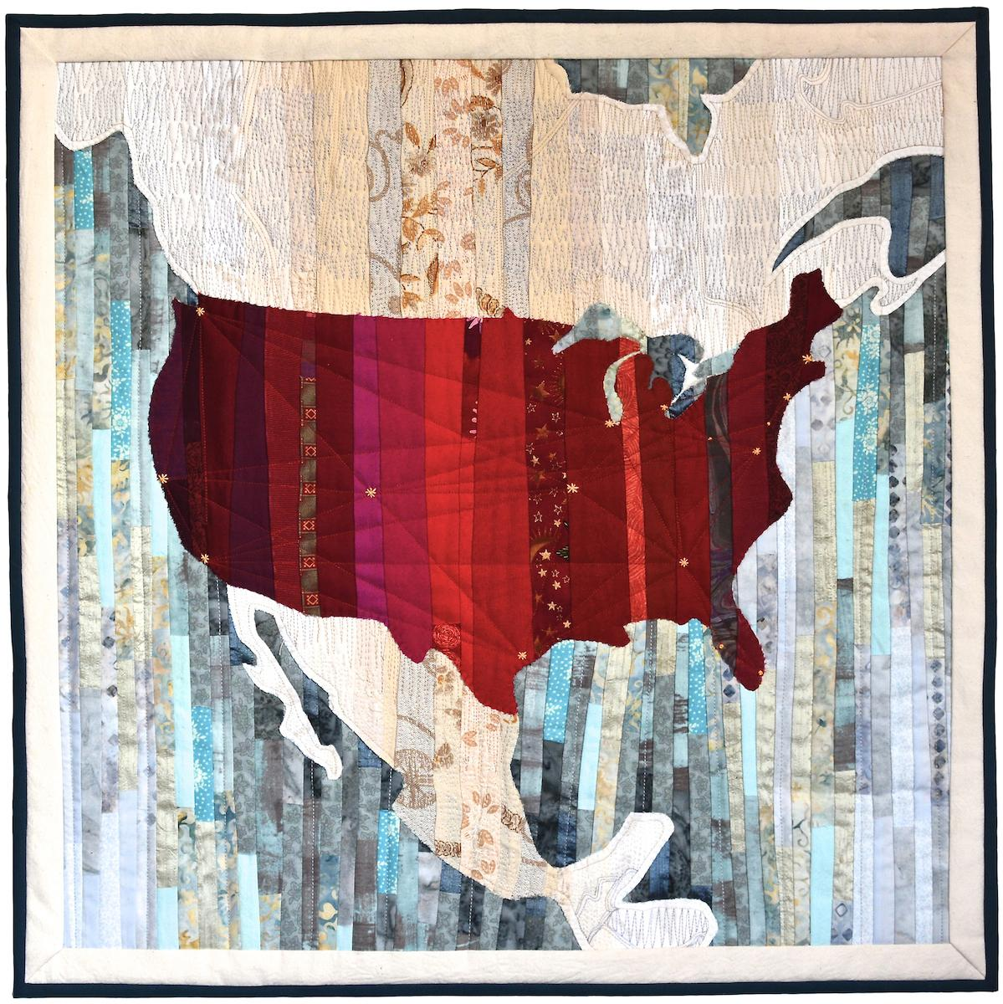

USA
30 x 30"

Cotton, linen, and dupioni silk; rayon, silk and cotton thread; hand and machine quilted, hand-embroidered with silk and cotton floss. Cotton batting and backing.

A bold outline of these United States of America using a color palette that celebrates difference and inclusiveness while recognizing common ground.

